Build and modernize AI Apps on Azure
95 Hr 9 Min Remaining
Instructions Resources Help 100%

Lab 05 - .NET - Dev - Integrating Azure SQL Database into a webapp
Estimated duration: 40 minutes
Lab Type: Instructor Led
Objective
Azure App Service provides a highly scalable, self-patching web hosting service. In this lab, you will learn how to deploy a data-driven ASP.NET app in App Service and connect it to Azure SQL Database. When you're finished, you have an ASP.NET app running in Azure and connected to SQL Database.
...less

Exercise 1: Deploying an ASP.NET app to Azure with Azure SQL Database

Task 1: Set up Visual Studio 2022 and run the application
- From the Windows Search bar, type Visual studio and select Visual Studio 2022. If it asks you to Sign in, continue with the steps 2 and 3 or continue from Step 4.
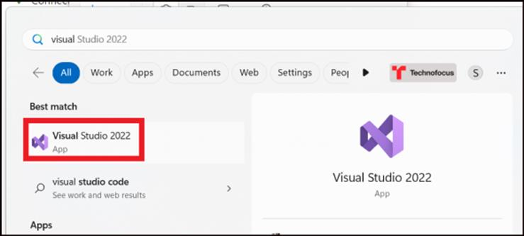
- Click on Sign in and Sign in using your Office 365 admin tenant credentials.
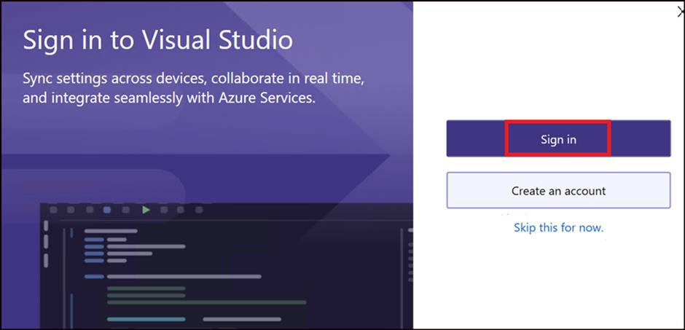
- Select Start Visual Studio.
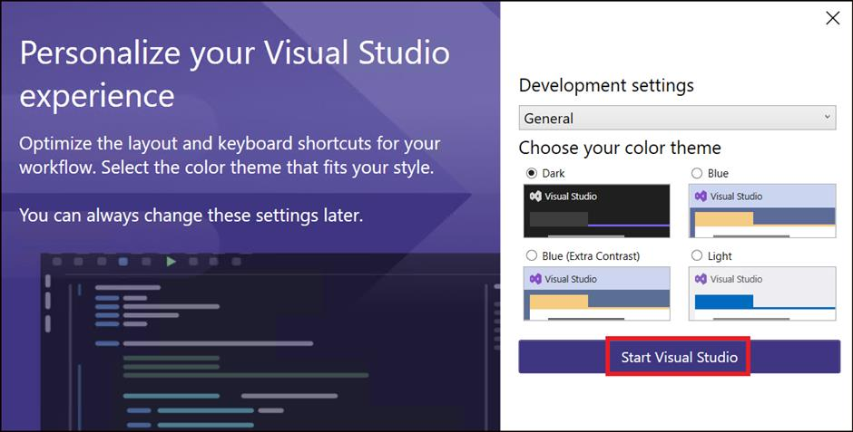
- Select Open a local folder.
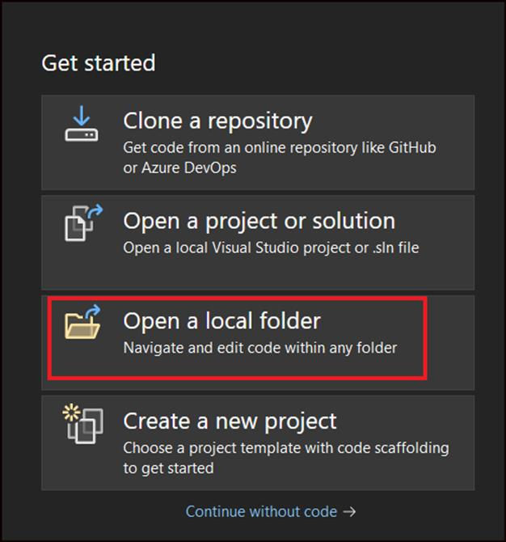
- Select webappwithsqldb folder in C:\Labfiles and click on Select Folder.
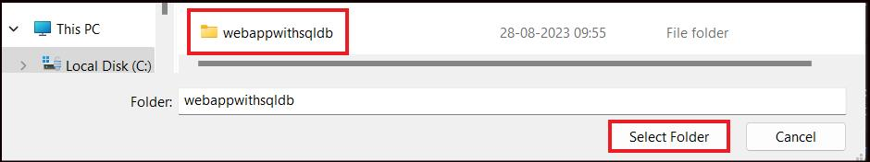
- Once the folder is opened, double click on DotNetAppSqlDb.sln from the Solution Explorer.
Note: If the Solution Explorer does not get opened automatically, Click on View -> Solution Explorer.
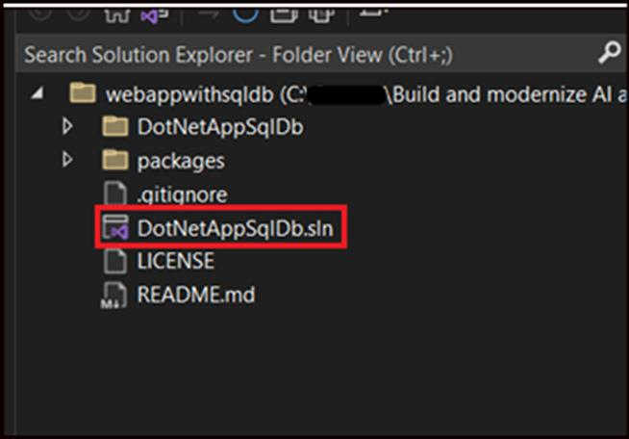
- Click on Build -> Build Solution.
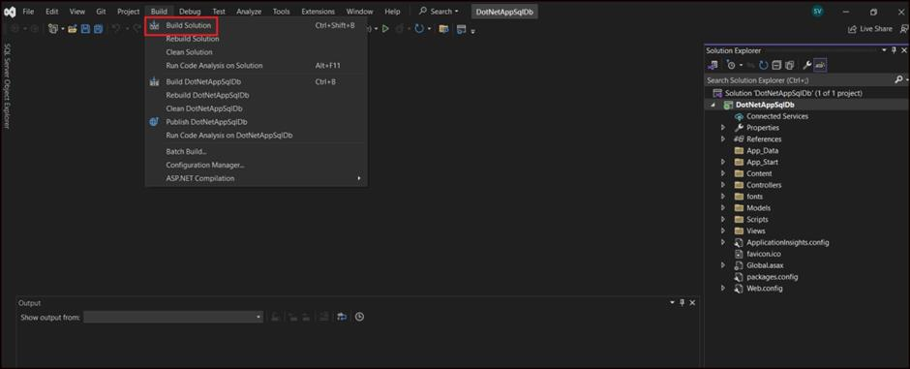
- Once the Build is completed, select Debug -> Start Debugging.
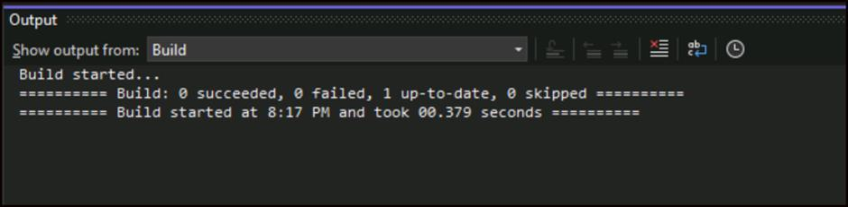
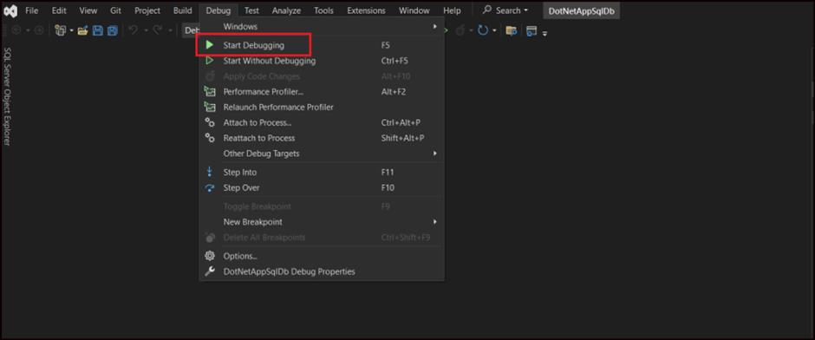
- This opens up a browser with the Todos web app running in it.
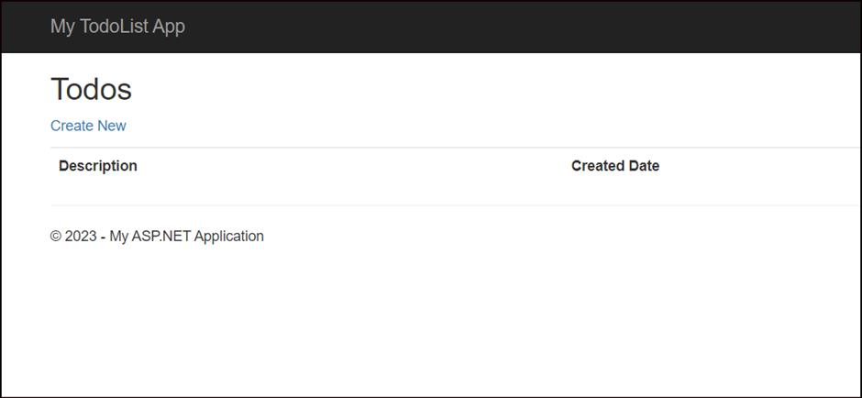
- Add few items into the app by clicking on Create New as in the screenshots below.
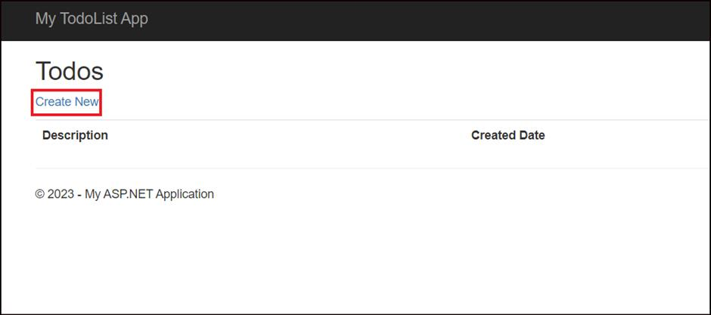
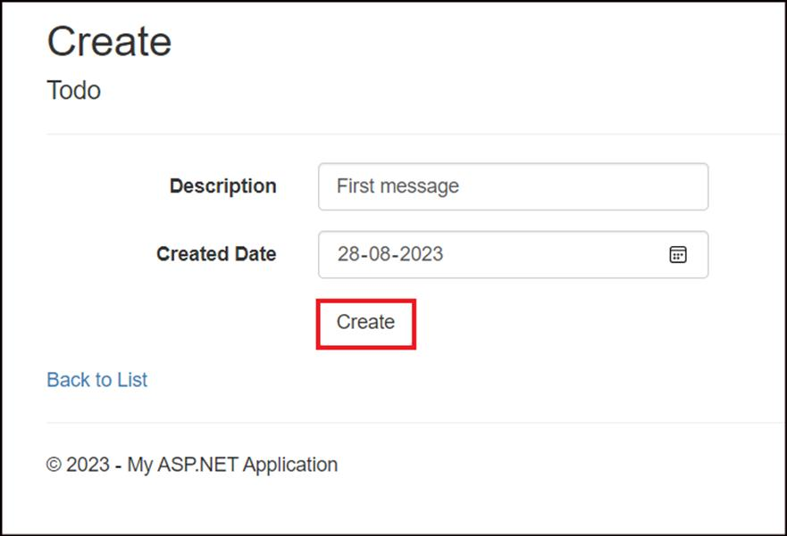
- Add few more items to the list.
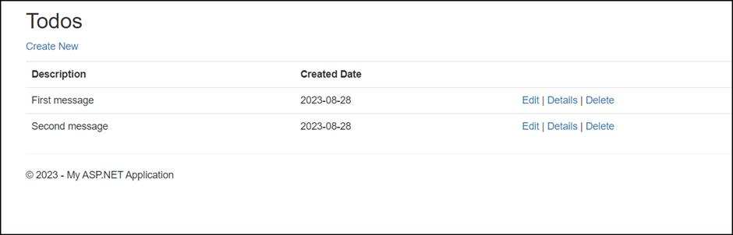
- Click on Stop Debugging.
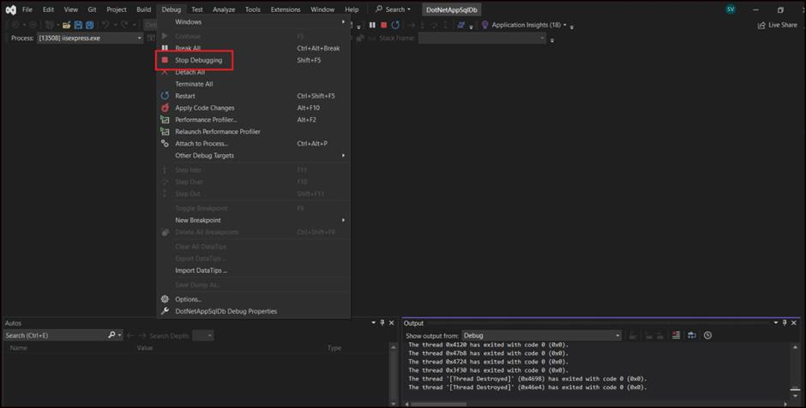

Task 2: Publish ASP.NET application to Azure
- In the Solution Explorer, right-click on your DotNetAppSqlDb project and select Publish.
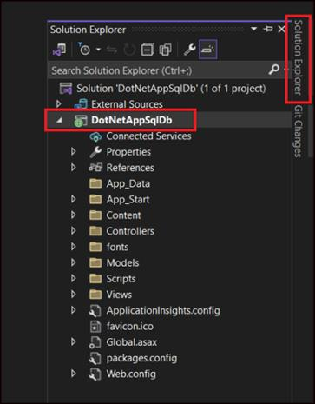
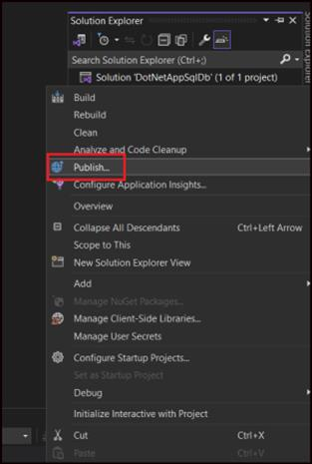
- Select Azure and and click on Next.
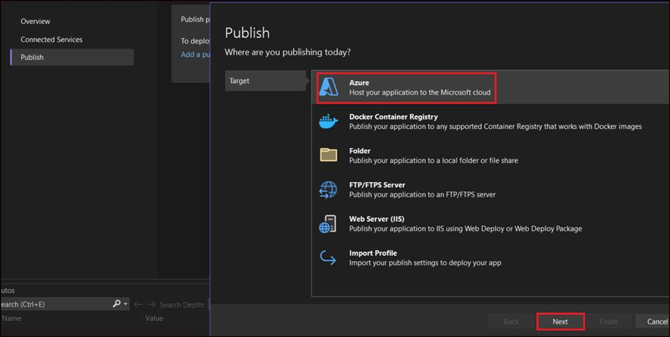
- Select Azure App Service(Windows) in Which Azure service would you like to use to host your application? Screen and click on Next.
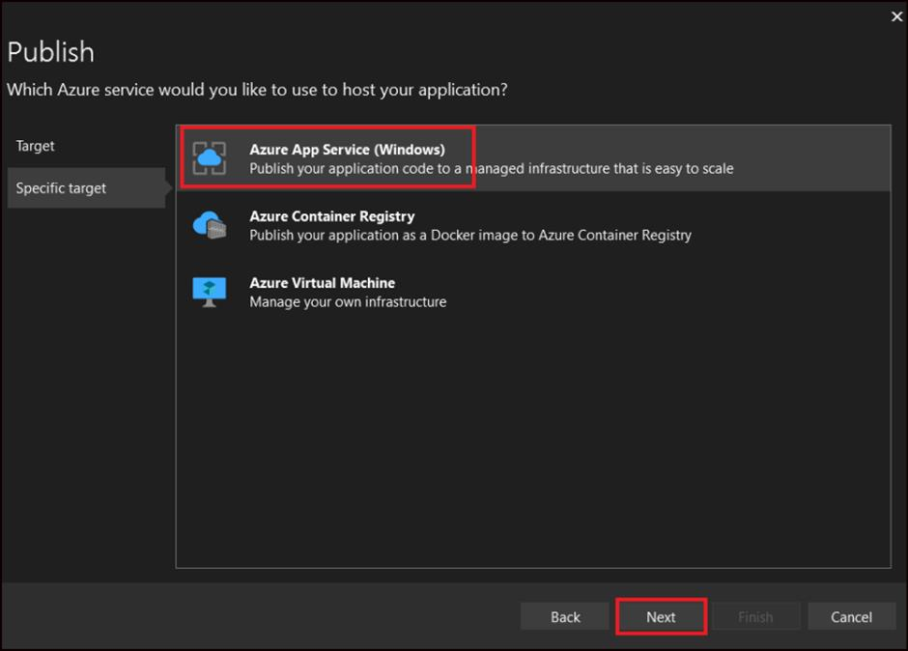
- In the Publish dialog, click Sign In and Sign in to your Azure subscription, if not signed in already.
Note: You're already signed into a Microsoft account, make sure that account holds your Azure subscription. If the signed-in Microsoft account doesn't have your Azure subscription, click it to add the correct account.
- Click on Create new to create a new App service.
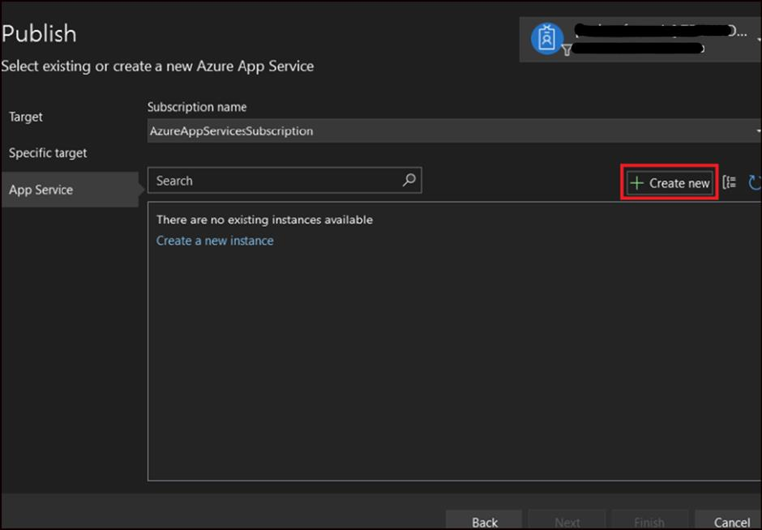
- Enter the below details.
Property | Description
Name | TodoAppXX(Replace XX with a unique number since the Webapp name should be unique across Azure)
Resource group | Click on New -> RGForWebAppSQL and click on OK
- 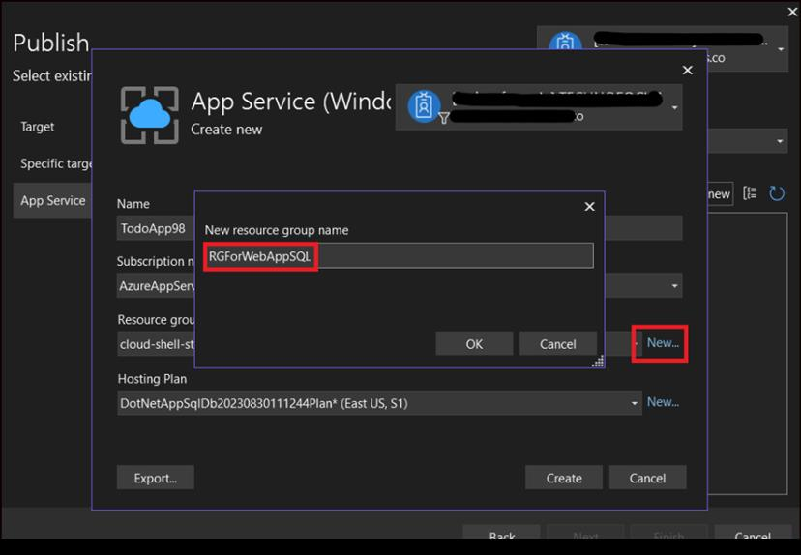
- Click New on Hosting Plan option and enter the below details and click OK.
Property | Description
Hosting Plan | myAppServicePlan
Location | East US
Size | Free
- 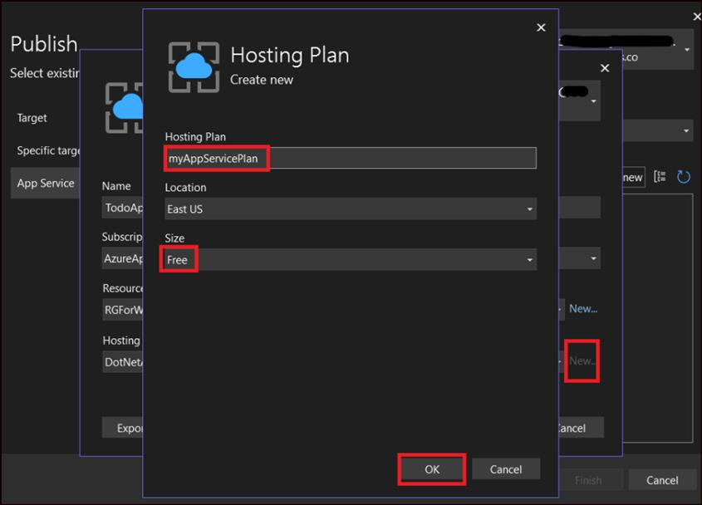
- Click Create on the App Service window and wait for Azure resources to get created.
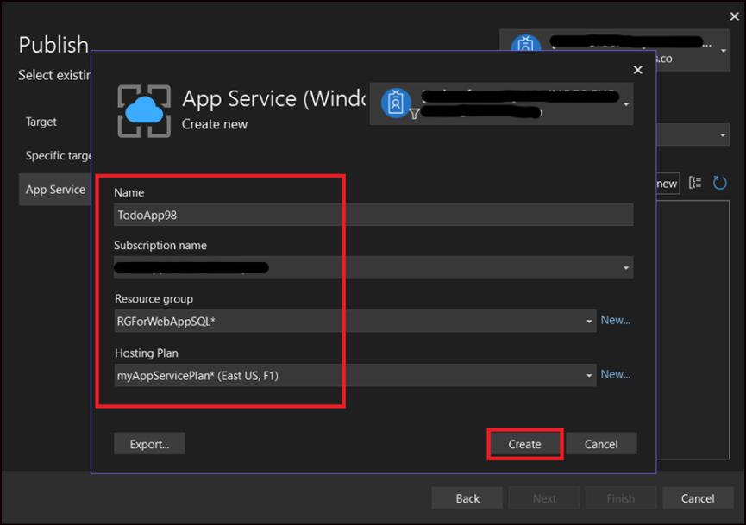
- The Publish dialog shows the resources you have configured. Click Finish.
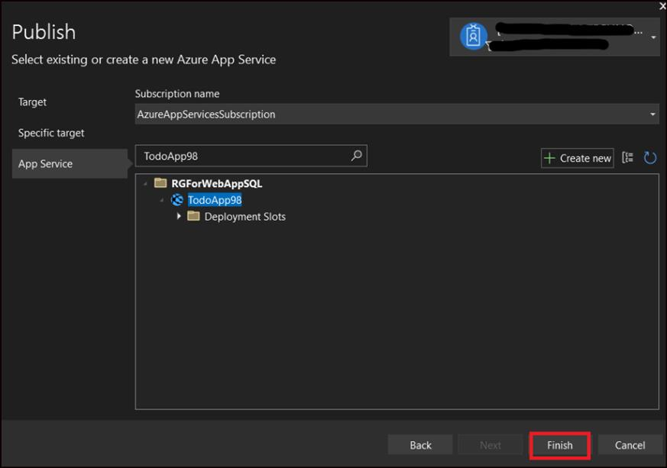
- Click on Close.
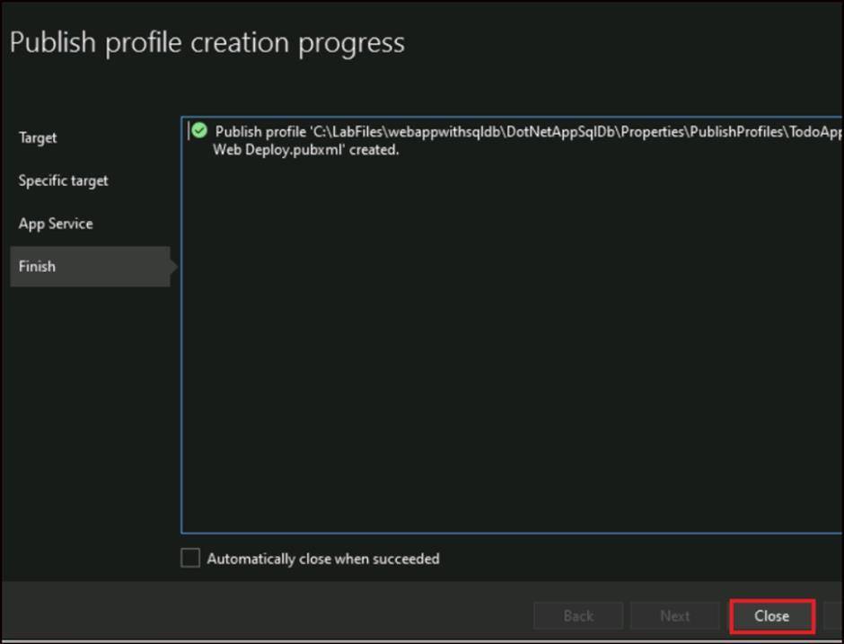
- Scroll down to the Server Dependencies section and click on the + sign to add dependency.
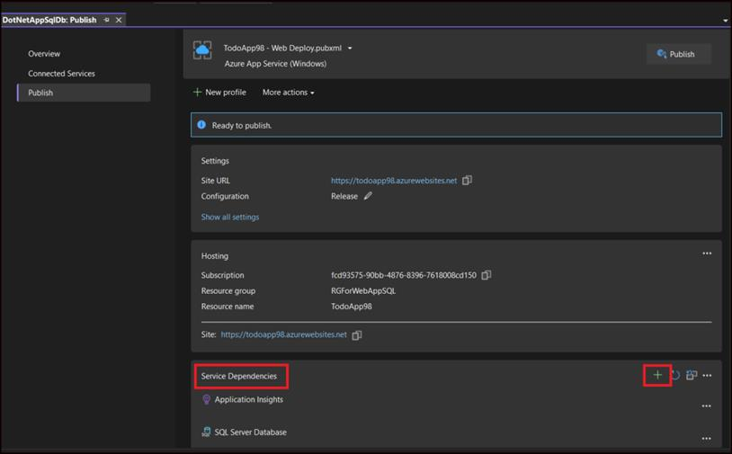
- Select Azure SQL Database in the Add dependency page and click on Next.
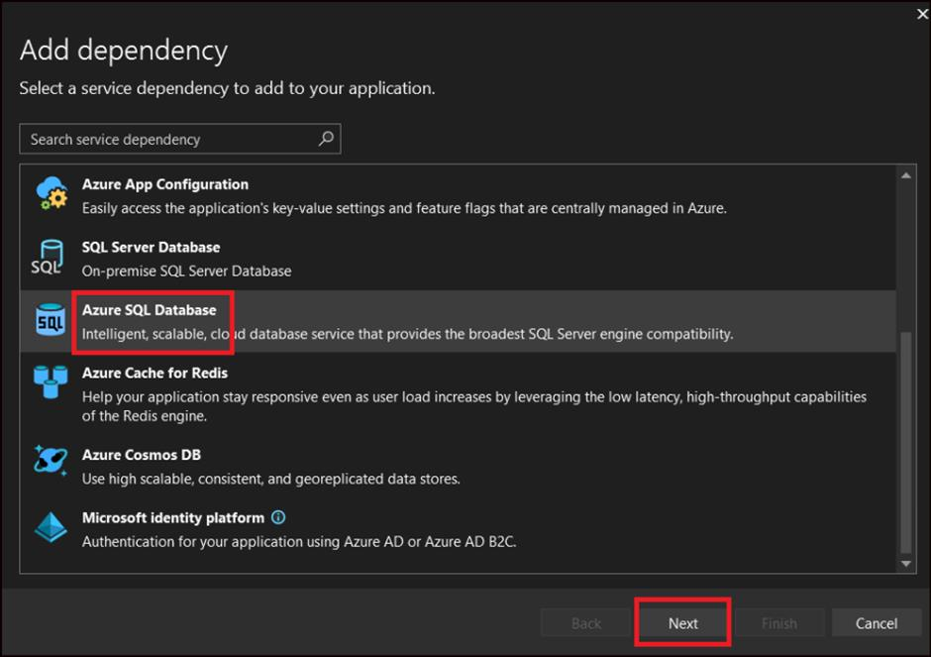
- Click on Create New next to SQL databases, in the Connect to Azure SQL Database dialog box.
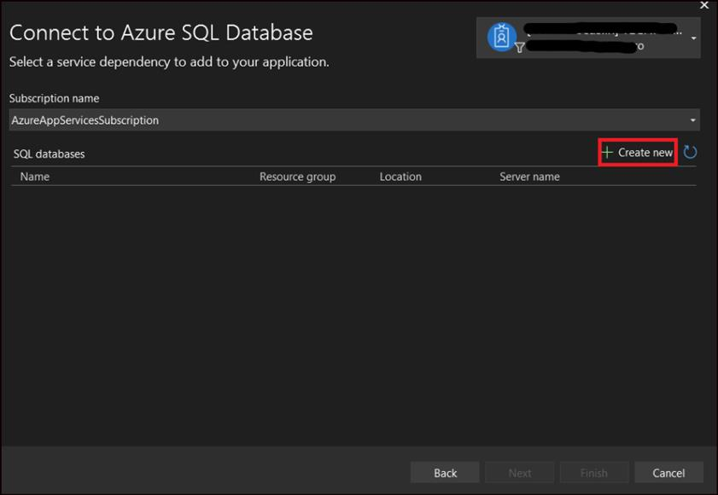
- In the Azure SQL Database Create new dialog box, click on New next to the Database server.
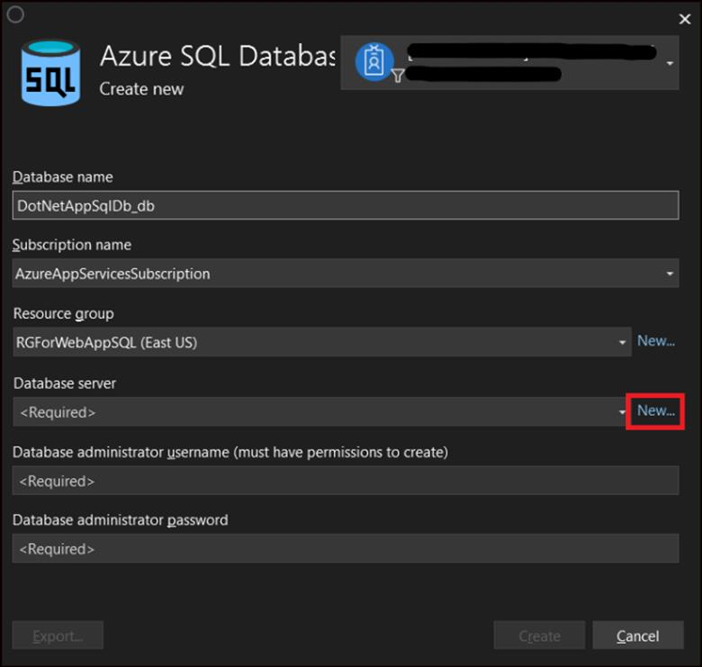
- Fill in the below details and click on OK.
Property | Description
Database server name | dotnetappsqldbdbserver98
Administrator username | sqladmin
Administrator password | PassWord98
- 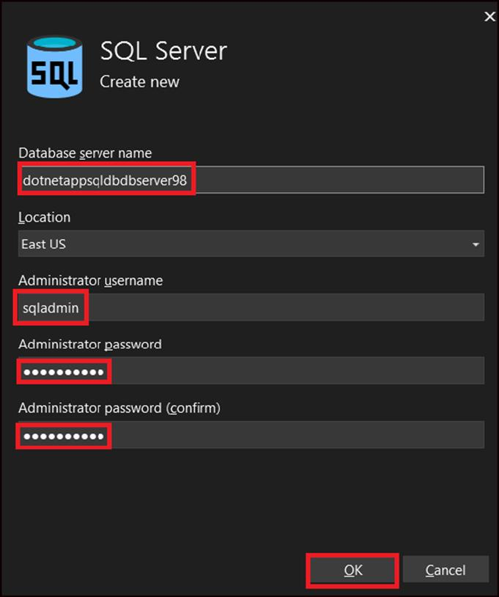
- Click on Create in the Create new dialog.
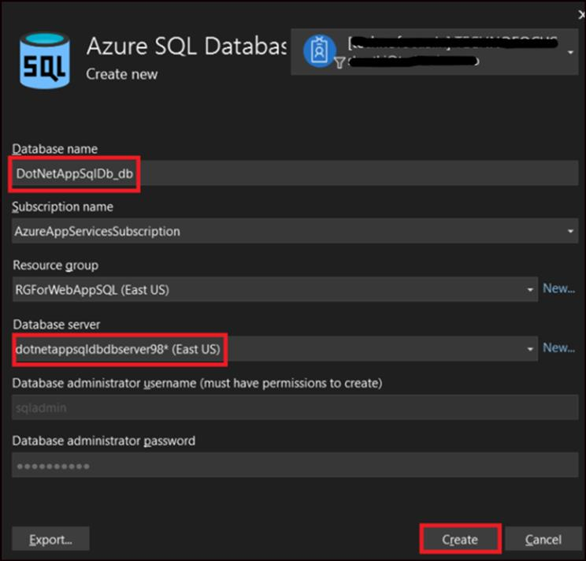

Task 3: Configure database connection
- When the wizard finishes creating the database resources, click Next.
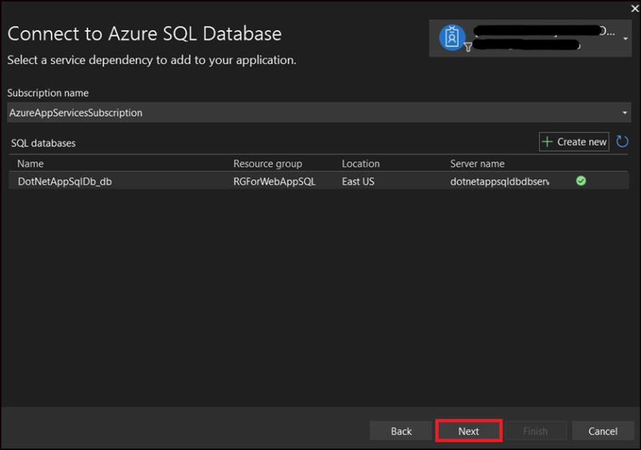
- Fill in the below details in the Connect to Azure SQL Database dialog and click Finish.
Property | Value
Database connection string Name | MyDbConnection
Database connection user name | Sqladmin
Database connection password | PassWord98
Azure App Settings | Selected
- 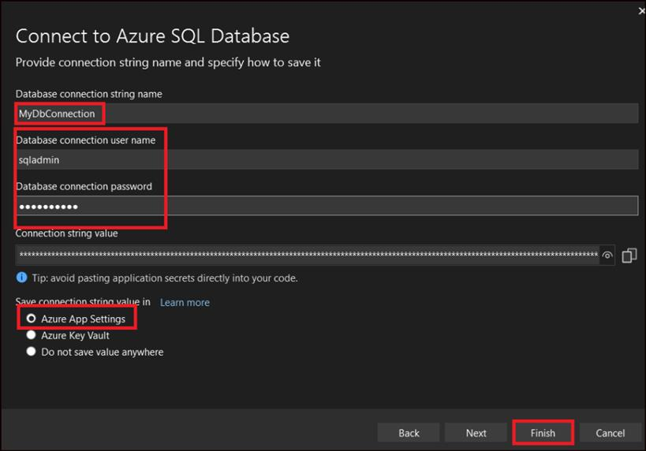
- Wait for configuration wizard to finish and click Close. The Azure SQL Db is now connected to your app.
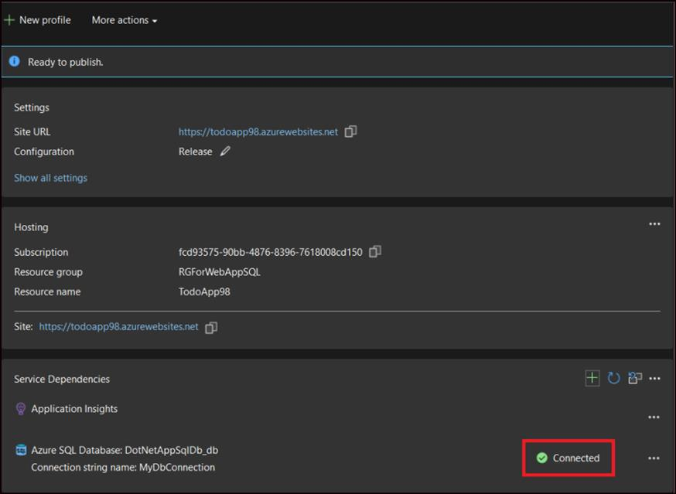
- From the Publish page, click Publish on the top right corner.
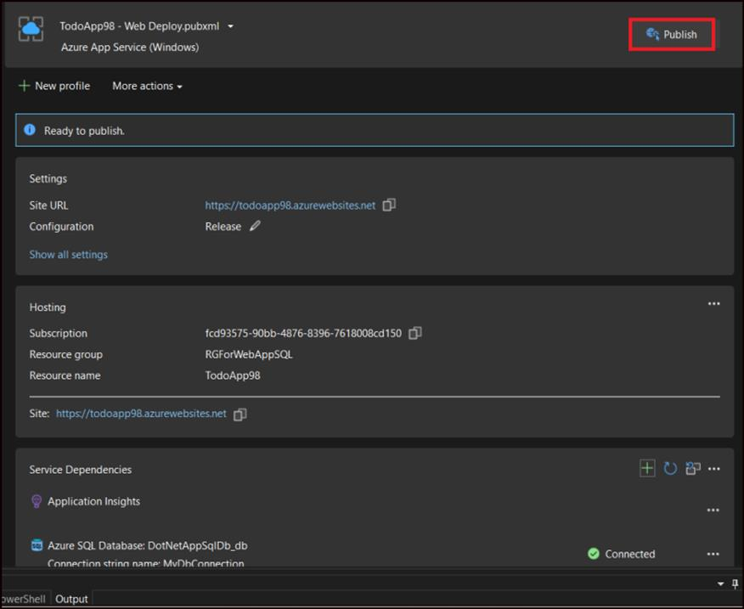
- Once your ASP.NET app is deployed to Azure, your default browser is launched with the URL to the deployed app. Add a few to-do items.
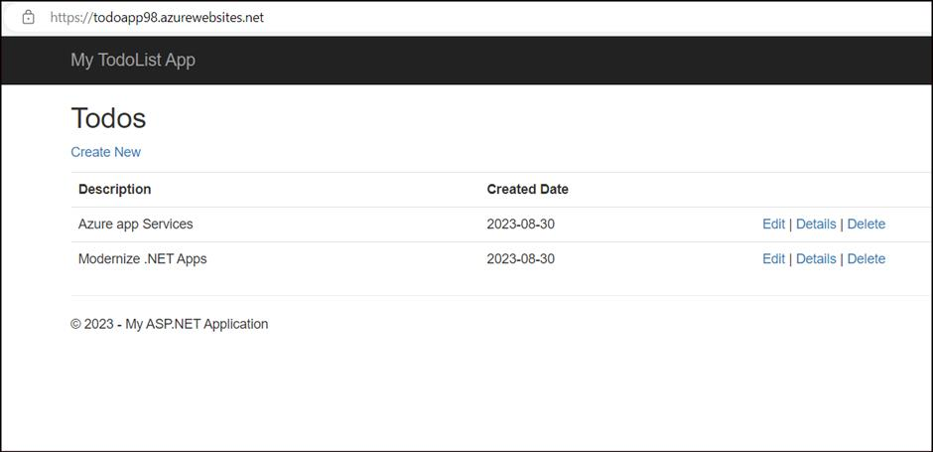

Task 4: Access the database locally
Visual Studio lets you explore and manage your new database in Azure easily in the SQL Server Object Explorer. The new database already opened its firewall to the App Service app that you created. But to access it from your local computer (such as from Visual Studio), you must open a firewall for your local machine's public IP address. If your internet service provider changes your public IP address, you need to reconfigure the firewall to access the Azure database again.
- From the View menu, select SQL Server Object Explorer.
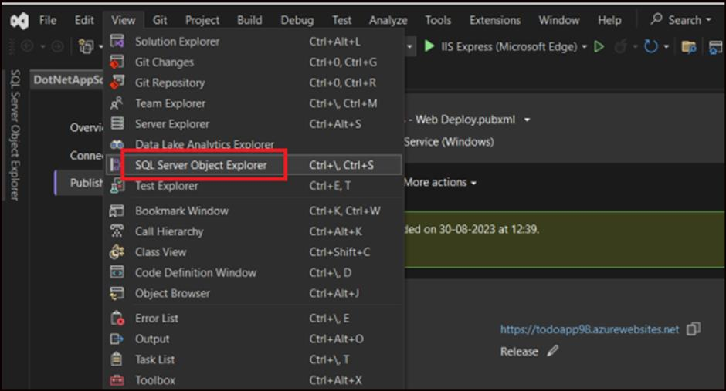
- At the top of SQL Server Object Explorer, click the Add SQL Server button.
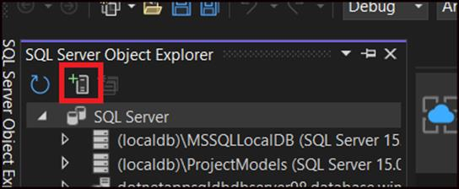

Task 5: Configure the database connection
- In the Connect dialog, expand the Azure node. All your SQL Database instances in Azure are listed here.
- Select the database that you created earlier(dotnetappsqldbdbserver98). The connection you created earlier is automatically filled at the bottom.
- Type the database administrator password you created earlier(PassWord98 ) and click Connect.
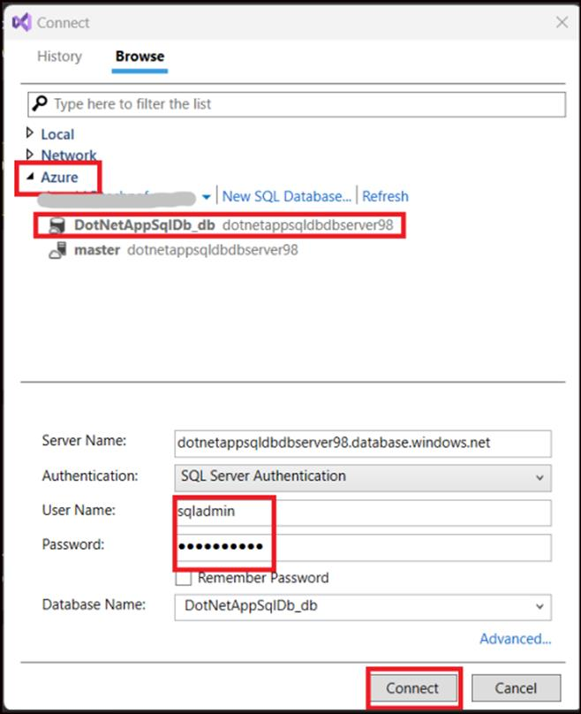

Task 6: Allow client connection from your computer
The Create a new firewall rule dialog is opened. By default, a server only allows connections to its databases from Azure services, such as your Azure app. To connect to your database from outside of Azure, create a firewall rule at the server level. The firewall rule allows the public IP address of your local computer.
The dialog is already filled with your computer\'s public IP address.
- Make sure that Add my client IP is selected and click OK.
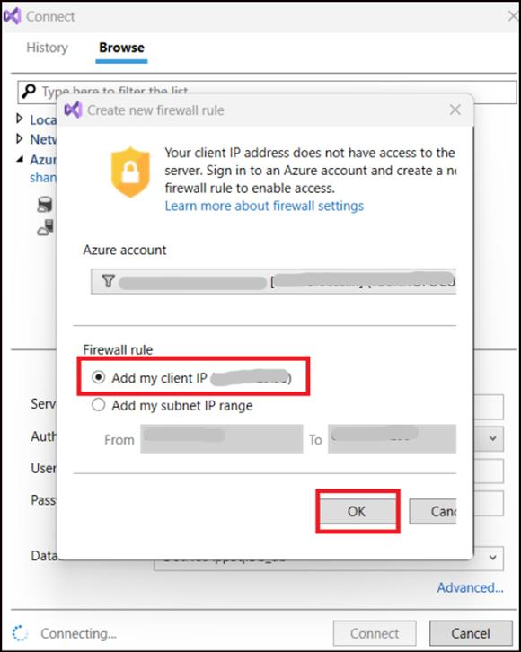
- Once Visual Studio finishes creating the firewall setting for your SQL Database instance, your connection shows up in SQL Server Object Explorer.
- Expand your connection > Databases -> <your database> -> Tables.
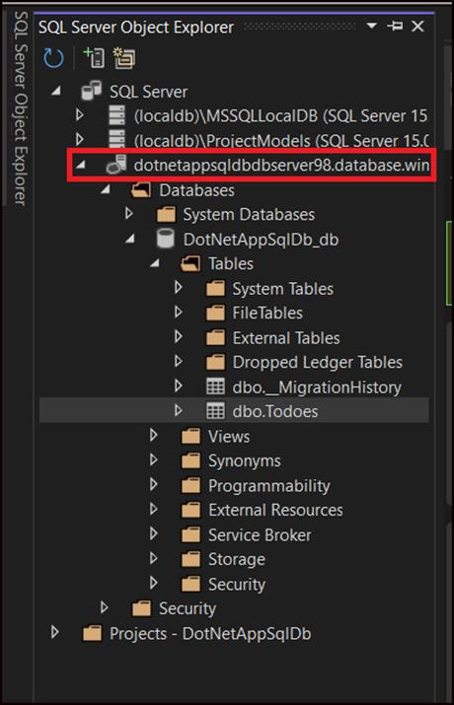
- Right-click on the Todoes table and select View Data.
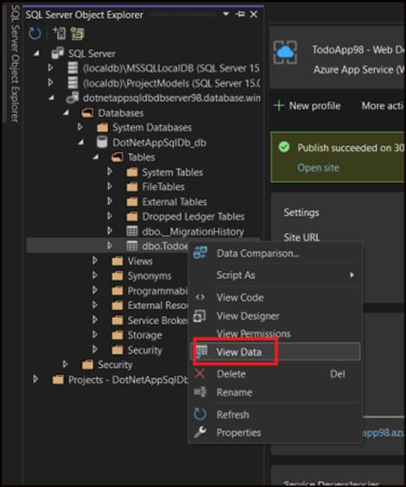
- View the contents of the table.
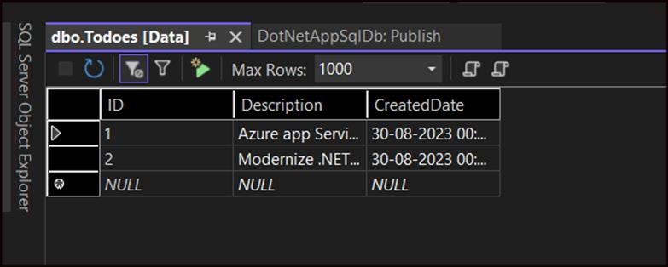

Exercise 2: Update app with Code First Migrations
- From the Solution Explorer, Open Models\Todo.cs in the code editor. Add the following property to the ToDo class as the last line (after the public DateTime CreatedDate { get; set; } line ) and click on Save.
public bool Done { get; set; }
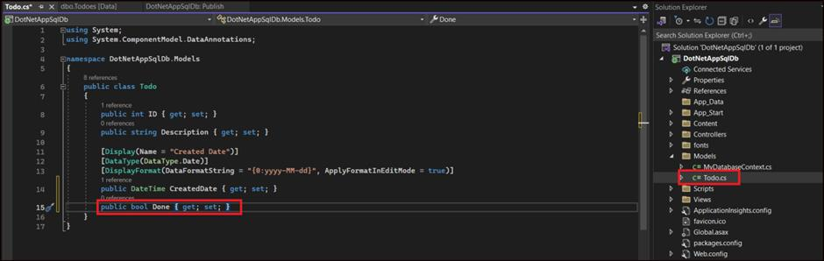

Task 1: Run Code First Migrations locally
Run a few commands to make updates to your local database.
- From the Tools menu, click NuGet Package Manager > Package Manager Console.
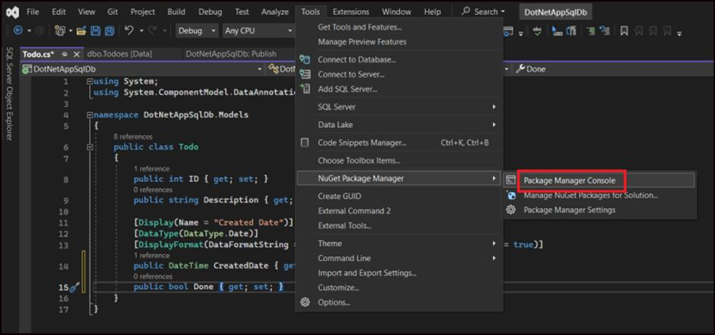
- In the Package Manager Console window, enable Code First Migrations by executing this command.
Enable-Migrations
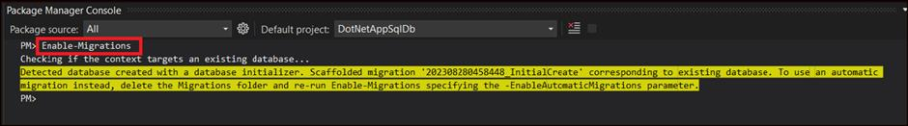
- Add a migration by executing the below command.
Add-Migration AddProperty
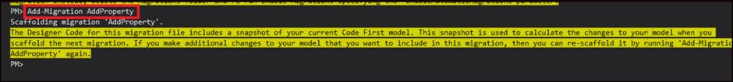
- Update the local database by executing the below command.
Update-Database
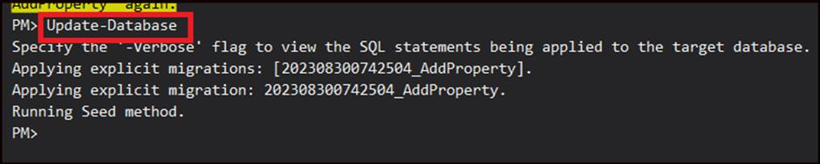
- Type Ctrl+F5 to run the app or click on Debug -> Start without Debugging. Test the edit, details, and create links.
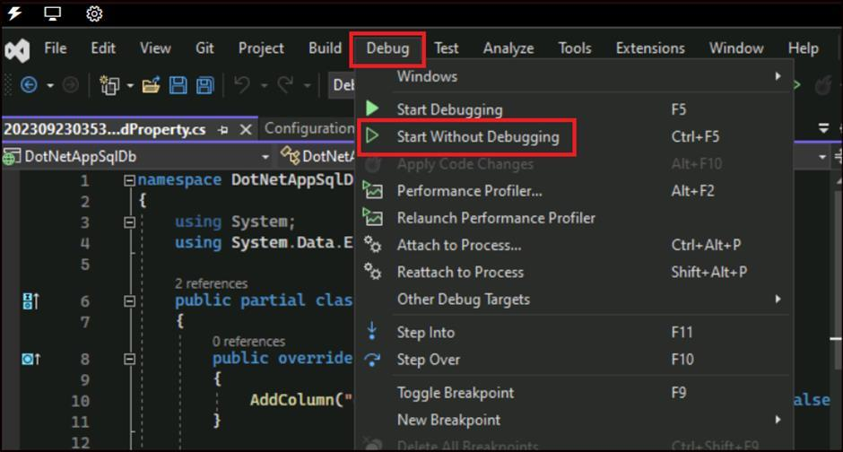
- The application page opens up and it still looks the same because your application logic is not using this new property yet.
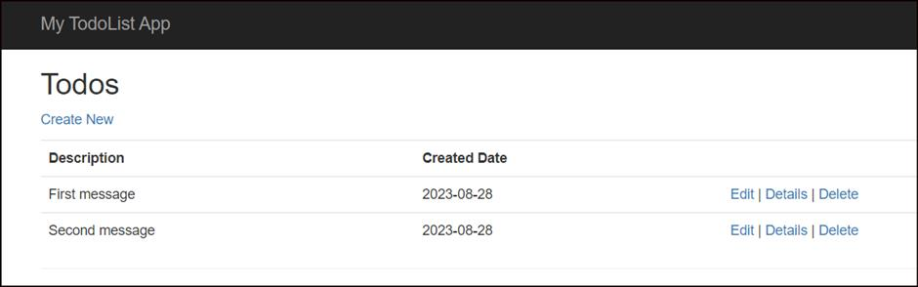

Task 2: Use the new property
Make some changes in your code to use the Done property.
- Open Controllers\TodosController.cs. Find the Create() method on line 52 and add Done to the list of properties in the Bind attribute. When you're done, your Create() method signature look like the following code:
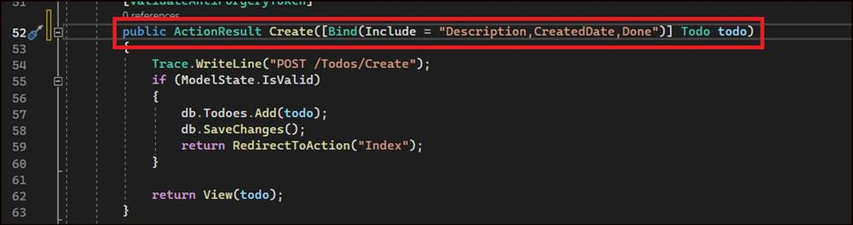
- Open Views\Todos\Create.cshtml. Add the following code after the < div class="form-group" > for CreatedDate.
- <div class="form-group">
- @Html.LabelFor(model => model.Done, htmlAttributes: new { @class = "control-label col-md-2" })
- <div class="col-md-10">
- <div class="checkbox">
- @Html.EditorFor(model => model.Done)
- @Html.ValidationMessageFor(model => model.Done, "", new { @class = "text-danger" })
- </div>
- </div>
</div>
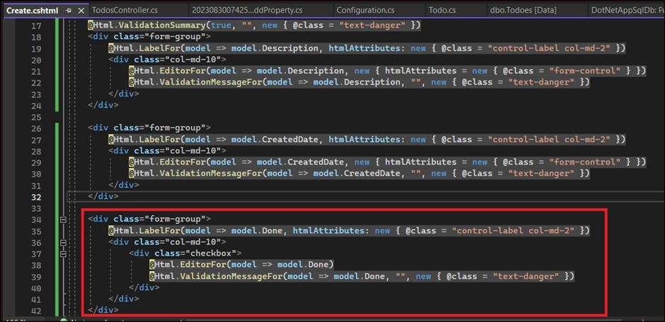
- Open Views\Todos\Index.cshtml. Add the following code in the empty th element, after the th element for the CreatedDate.
@Html.DisplayNameFor(model => model.Done)
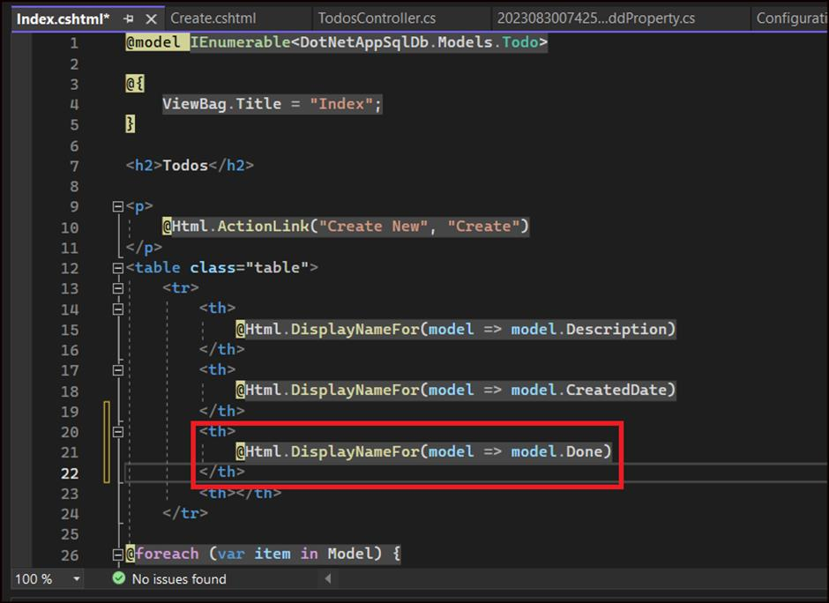
- Add this code just above the html.ActionLink() helper methods.
- <td>
- @Html.DisplayFor(modelItem => item.Done)
</td>
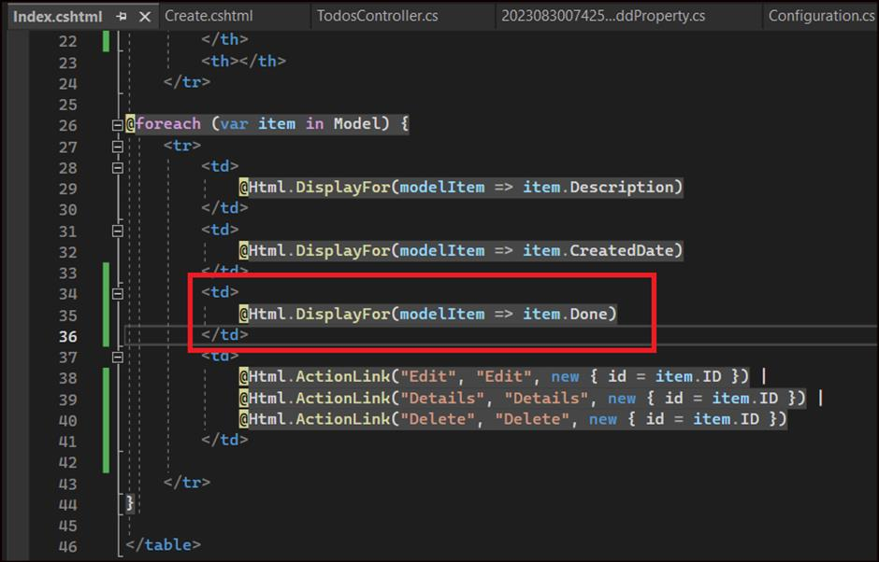
- Type Ctrl+F5 to run the app.
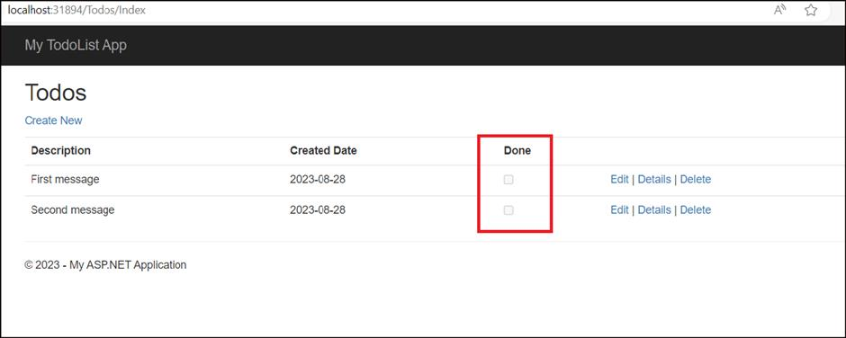

Task 3: Enable Code First Migrations in Azure
- Right click on the project and select Publish.
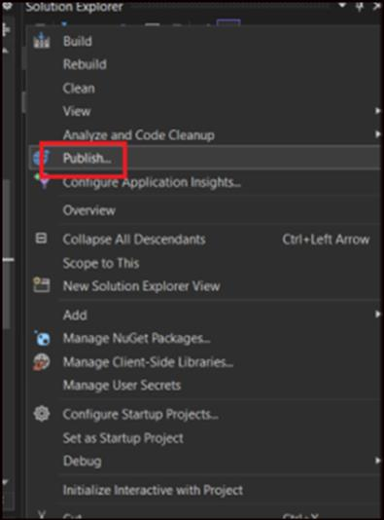
- Click More actions > Edit to open the publish settings.
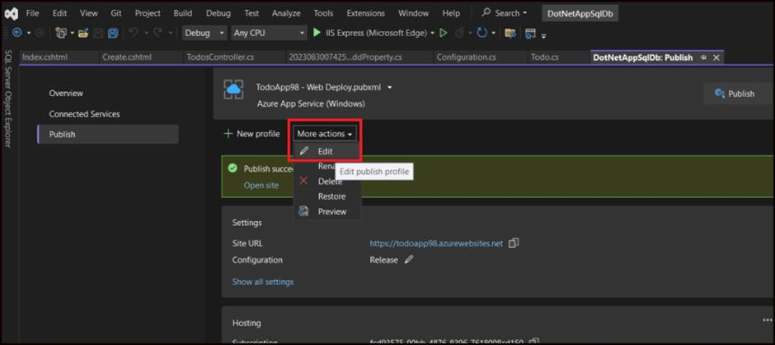
- In the MyDatabaseContext dropdown, select the database connection for your Azure SQL Database.
- Select Execute Code First Migrations (runs on application start), then click Save.
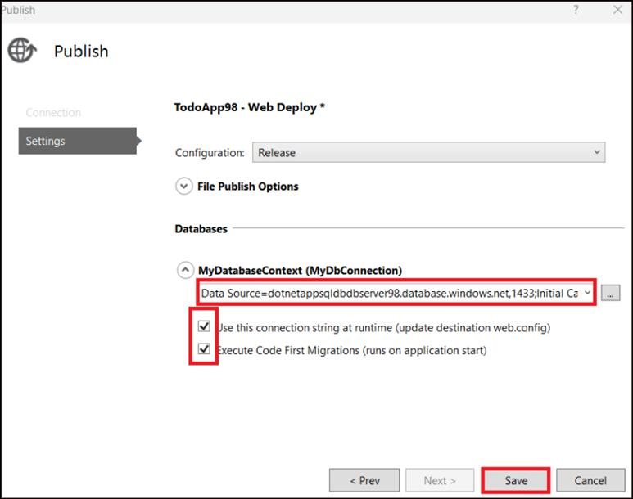
- In the Publish page, click on Publish.
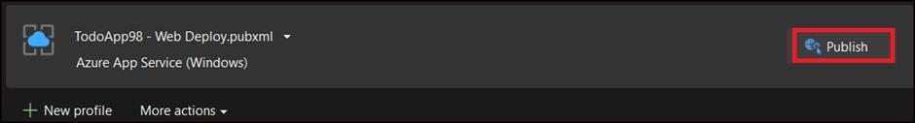
- The updated app is now available on Azure.
- Try adding to-do items again and select Done, and they should show up in your homepage as a completed item.
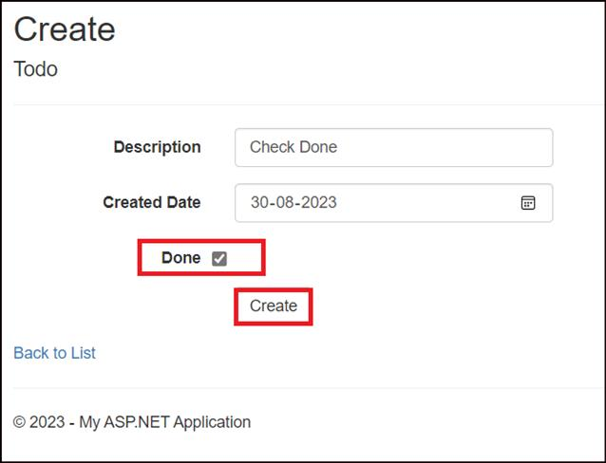
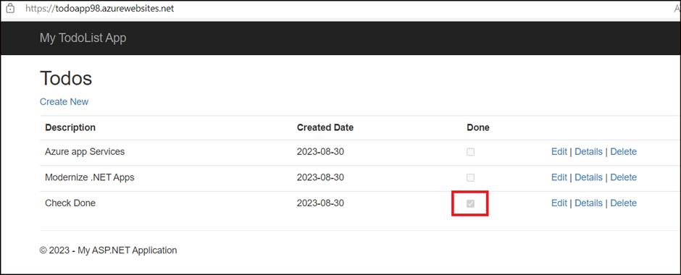

Exercise 3: Stream application logs
- In the publish page, scroll down to the Hosting section. At the right-hand corner, click ... > View Streaming Logs.
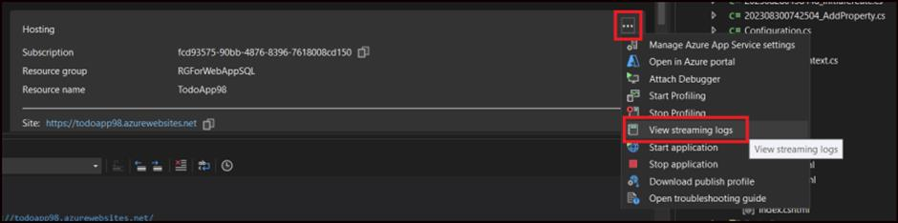
- The logs are now streamed into the Output window.
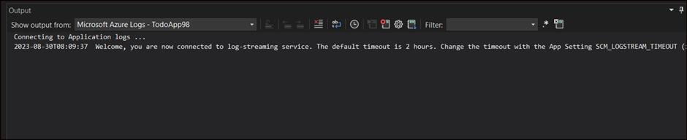
- You don't see any of the trace messages yet because, when you first select View Streaming Logs, your Azure app sets the trace level to Error, which only logs error events.

Task 1: Change trace levels
- Go to the publish page. In the Hosting section, click ... > Open in Azure portal.
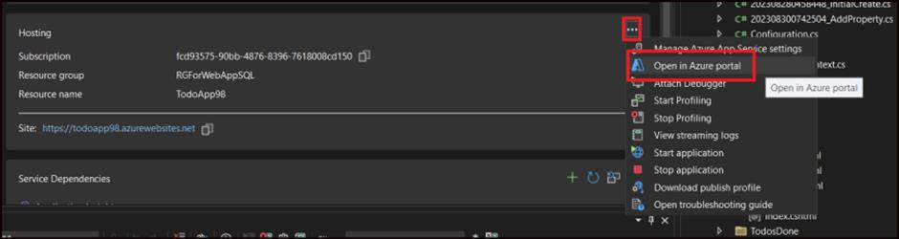
- In the Azure portal -- app page, select App Service Logs from the left pane.
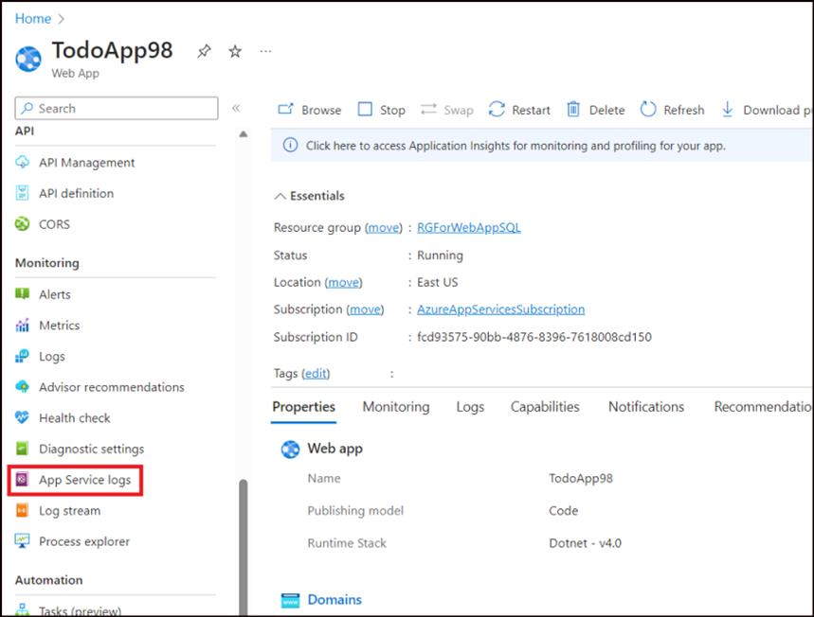
- Under Application Logging (File System), select Verbose in Level. Click Save.
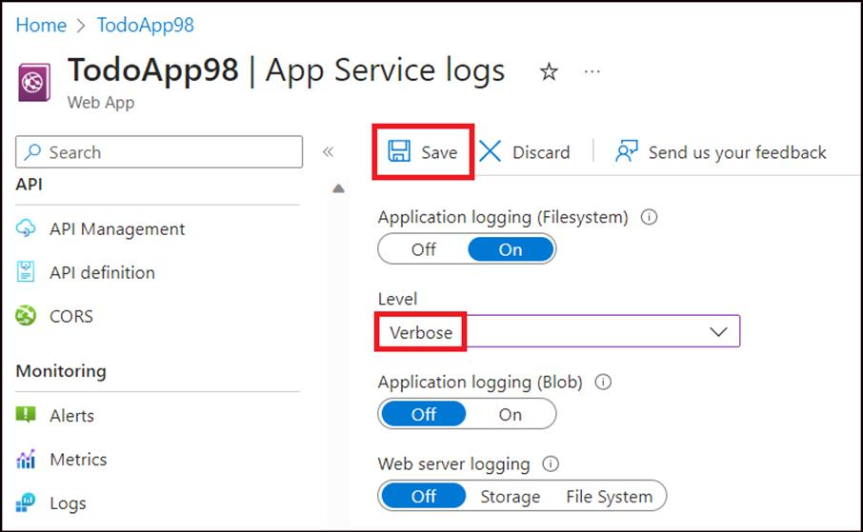
- From your browser, access the web app on Azure and do some activities.
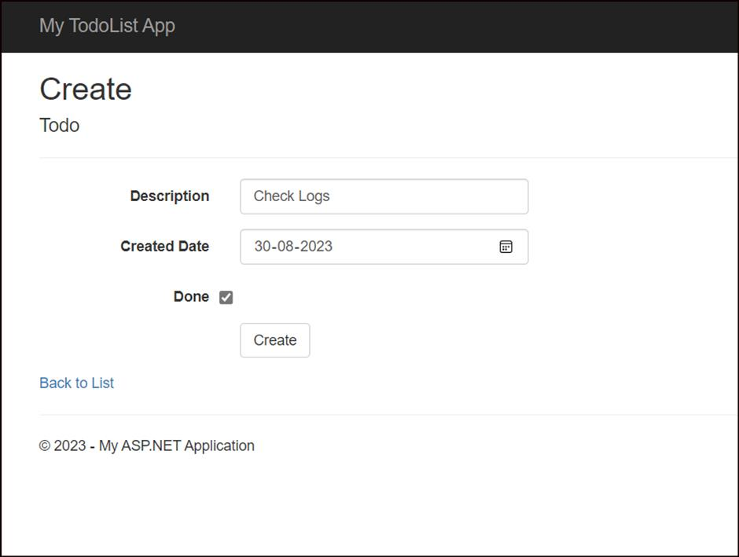
- The trace messages are now streamed to the Output window in Visual Studio.
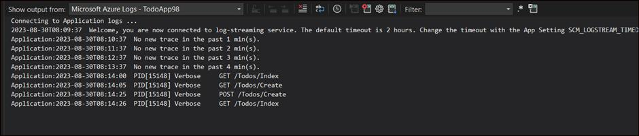
- To stop the log-streaming service, click the Stop monitoring button in the Output window.
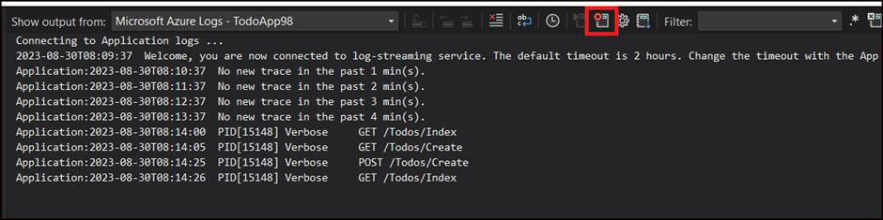
- Close the Visual Studio.

Exercise 4: Clean up resources
- From the Azure portal, open the Resourcegroup RGForWebAppSQL. Click on Delete resource group.
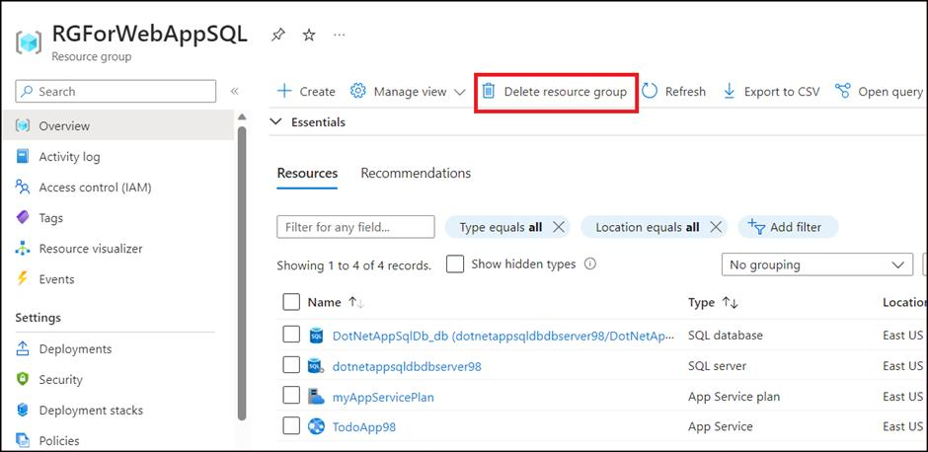
- Type the name RGForWebAppSQL and then click on Delete.
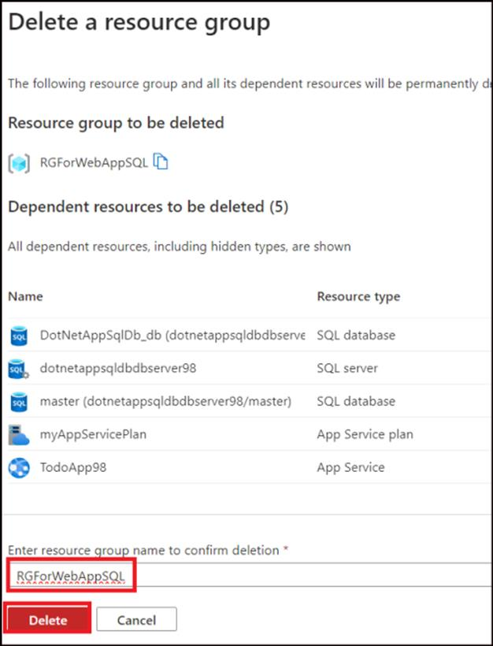
- Click Delete on the Delete confirmation dialog box.
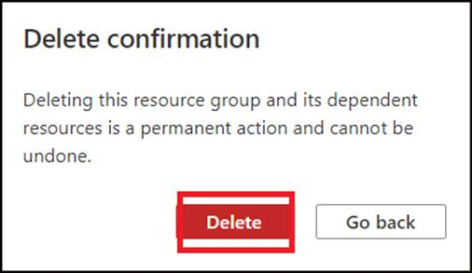
Summary
In this lab, you have learnt to deploy a data-driven ASP.NET app in App Service and connect it to Azure SQL Database.

